1. Intro

Create a pull request.

Retrieve and sync updates.

Develop on an active pull request.

Squashing commits with git rebase.

1. Create a Pull Request

A pull request is a request for the source repository to pull in your commits and merge them with their project. To create a pull request, a couple of things need to happen:

* you must fork the source repository
* clone your fork down to your machine
* make some commits (ideally on a topic branch!)
* push the commits back to your fork
* create a new pull request and choose the branch that has your new commits

1. Stay in sync with source project

Remember from the lesson on remotes that a git pull is the same thing as a git fetch + git merge!

# to make sure I'm on the correct branch for merging

$ git checkout master

# merge in Lam's changes

$ git merge upstream/master

# send Lam's changes to *my* remote

$ git push origin master

1. Manage an active PR
2. Squash Commits

Squashing is just taking a number of commits and combining them.

$ git rebase -i HEAD~3

This combines the last 3 commits into 1.

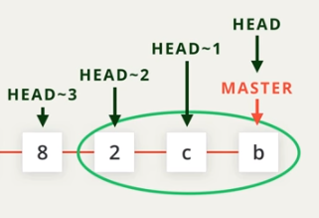

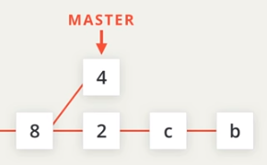

# interactive rebase

$ git rebase -i <base>

# interactively rebase the commits to the one that's 3 before the one we're on

$ git rebase -i HEAD~3

1. Course Wrap Up

Version control pro!